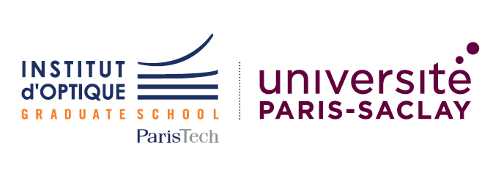
Institut d’Optique Graduate School
Diplôme d’Ingénieur – Master of Science in Engineering
Application For Degree Seeking Student
2021-2022

Please complete this form and send by Email
with required documents (see final page) to:
pierre.baladi@institutoptique.fr

Supporting documents may also be sent by post to:
Institut d’Optique Graduate School ID picture
Relations Internationales – Pierre Baladi
2, Avenue Augustin Fresnel
91127 PALAISEAU Cedex
France

Personal Information
Family or Last Name |  | First or given name(s)
Date and place of birth |  | Gender (M/F)
Permanent address |  | Temporary address and dates if applicable  (from now until dd/mm/yyyy)
E-mail address for correspondence |  | Telephone number  (e.g. +33-123 45 67 89)

Sending (Home) Institution
Name of Institution |  | Faculty
Erasmus Code  (if applicable) |  | Department
Address
Contact Person’s name |  | Contact Person’s e-mail and phone

Receiving Institution
Institut d’Optique Graduate School  (Institut d’Optique Théorique et Appliquée)  2 avenue Augustin Fresnel  Fr-91127 PALAISEAU Cedex  France |  | Erasmus Code:  F-ORSAY02 | Erasmus Charter number:  28120-LA-1-2014-1-FR-E4AKA1-ECHE
Contact Person | Pierre BALADI | Contact Person’s  e-mail and phone | pierre.baladi@institutoptique.fr  +33-164 53 32 08

Current year and field of study, with name of the degree programme (e.g. 3rd year student of Engineering Physics in 4 year BSc course)

Your application to the Master of Science in Engineering – Diplôme d’Ingénieur de l’Institut d’Optique programme as a degree-seeking student:

Language admission requirements (to be reached by September 2021 at latest):
- level of English should be at least B1/B2
- level of French should be at least B1/B2

Note: applications are normally for the 2-year programme (Master 1 & Master 2 years of the programme), both for the international and the usual track. But depending on their background, especially in physics and optical sciences, some applicants may be offered admission only for the 3-year programme (final Bachelor, Master 1 & Master 2 years): in that case, only the usual track is available.

Tuitions fees (per academic year) in 2020-2021:
- EU citizens: 2 900 euros
- Non-EU citizens: 5 000 euros

A partial tuition fees waiver is possible for students admitted under a Double-Degree agreement or some other specific programmes

Language skills:
ENGLISH LANGUAGE SKILLS
If English is not your first language, have you studied English?
If YES, give details and duration of study
Do you have an English language qualification (e.g. TOEFL, IELTS, Cambridge Certificates, etc.?)
If YES give name and date of exam and mark obtained (please enclose a copy of the score report)
Personal assessment of your English skills (CEFR - Common European Framework of Reference for Languages). Please tick appropriate box:
 | A1  Beginner | A2 Elementary | B1 Intermediate | B2 Upper Intermediate | C1  Advanced | C2 Proficiency
Reading
Writing
Speaking
Listening
Technical English

What is/are your native language(s)?

FRENCH LANGUAGE SKILLS
If French is not your first language, have you studied French?
If YES, give details and duration of study:
Do you have a French language qualification (e.g. DELF, DALF, TEF, etc.)?
If YES give name and date of exam and mark obtained (please enclose a copy of the score report)
Personal assessment of your French skills (CEFR - Common European Framework of Reference for Languages). Please tick appropriate box:
 | A1  Beginner | A2 Elementary | B1 Intermediate | B2 Upper Intermediate | C1  Advanced | C2 Proficiency
Reading
Writing
Speaking
Listening
Technical French

SUPPORTING DOCUMENTS

LIST OF DOCUMENTS THAT SHOULD BE SENT TO INSTITUT D’OPTIQUE WITH APPLICATION FORM
(please send all supporting documents in one single file, preferably a pdf file)

Required documents:

A letter outlining your motivation for study at Institute d’Optique (one page maximum)

A Curriculum Vitae,

The complete transcripts of your last years of study in higher education (for the current year, attach provisional results, if available); final transcripts/results must be sent as soon as possible,

At least 1 reference letter,

A scanned copy of your ID or Passport (identity photo page)

Additional documents:

Any other document supporting your academic profile (awards, prizes, olympiads…) or test results (language test, GRE…)

